Guideline

Trader (Oracle)

1. First we need to sign in from Oracle application as in to log in as a trader . Username is the registered email.

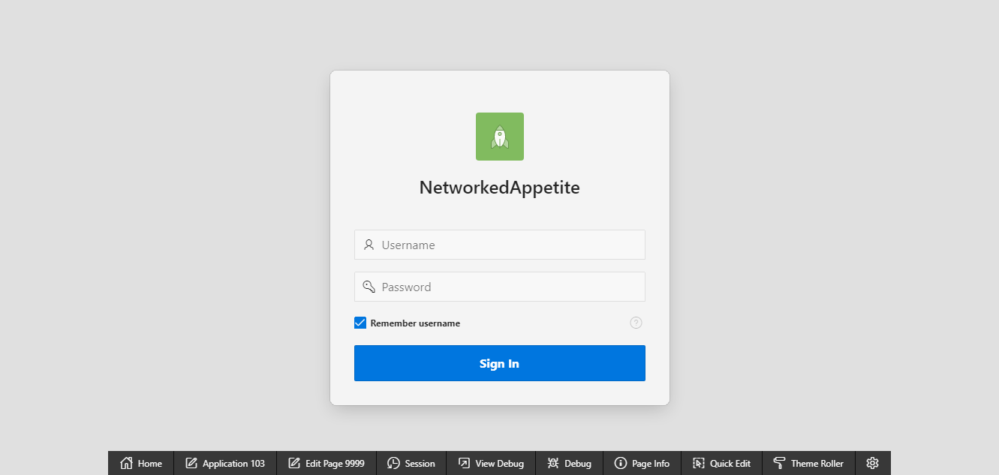

1. The following shop type can be chosen as per the trader. The trader can only login to their shop and they can only see their reports.

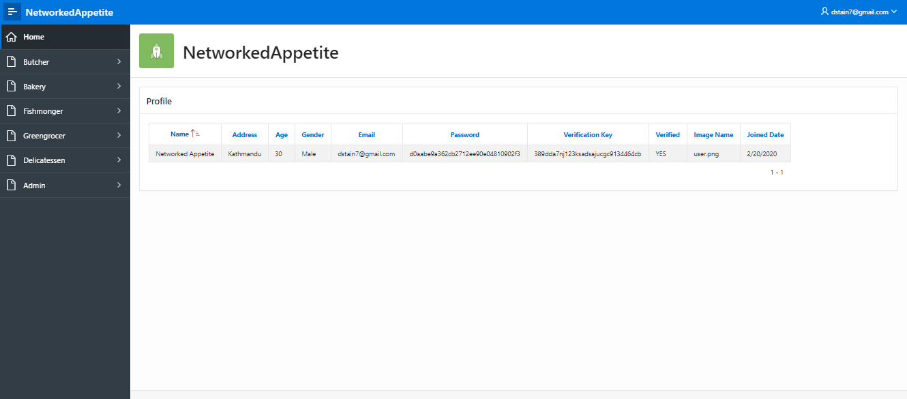

1. A trader can view their shop, product, discount and review.

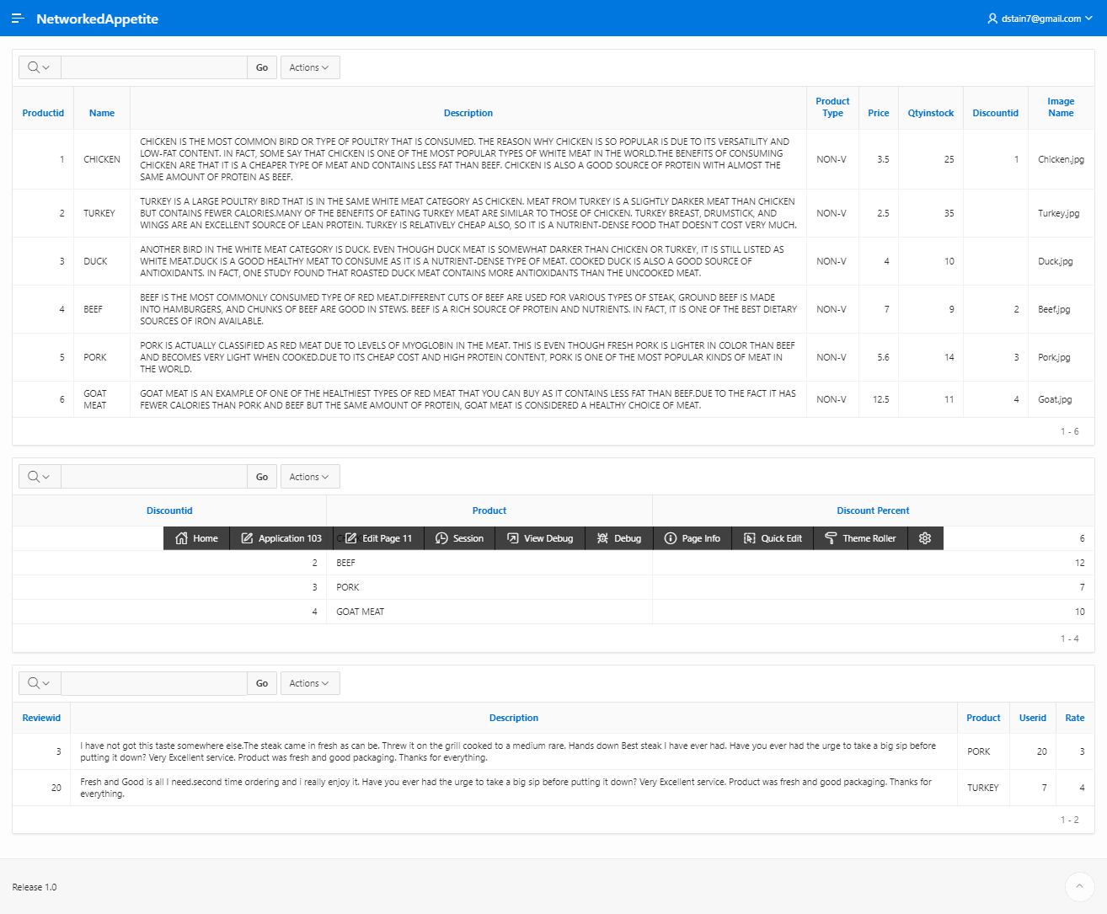

1. Trader can also see their daily report, weekly report and monthly reports.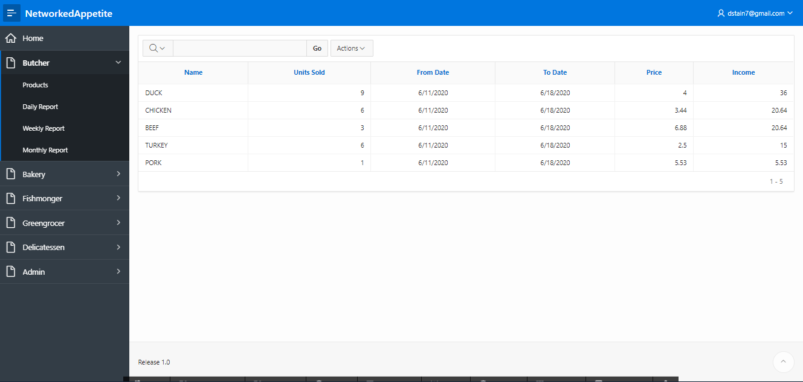
2. Order Report as to view product, quantity and price of a product that has been purchased by the customer from the following trader.

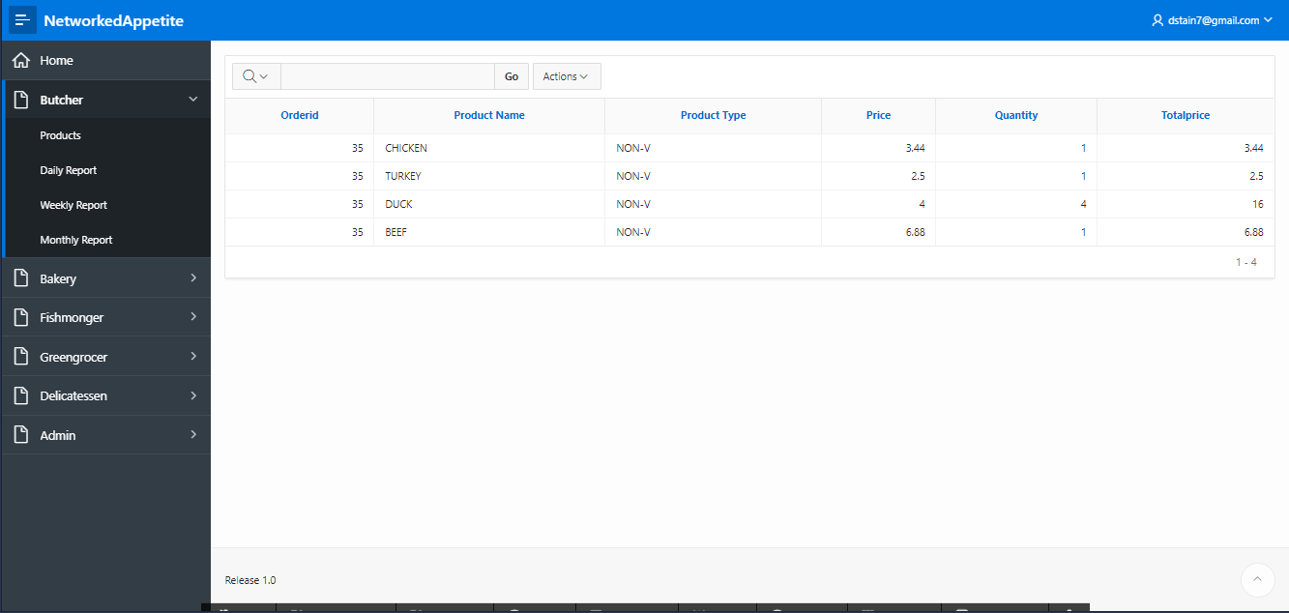

1. Trader can also view their dashboard to a range of daily and periodic reports.

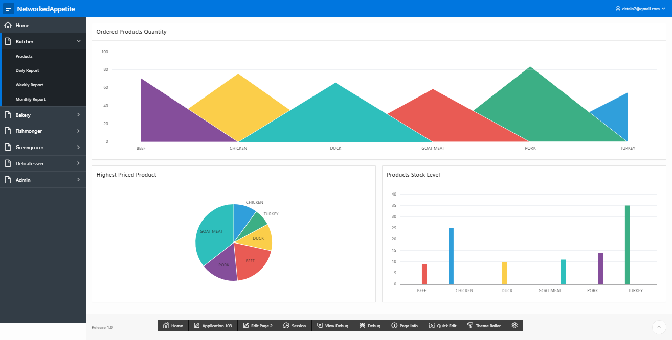

1. Logout

Trader can log out of this page from sign out button in the top right corner of the page.

